**Multi area OSPF project**

**topology**

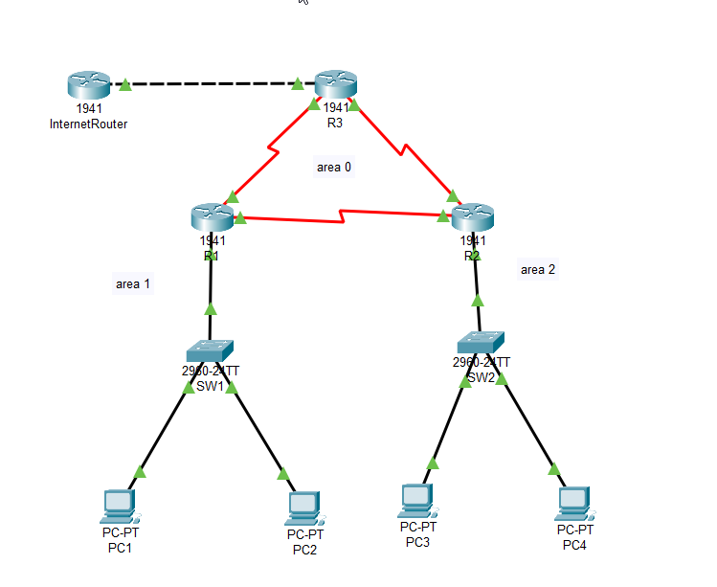

**Addressing table**

|  |  |  |  |  |
| --- | --- | --- | --- | --- |
| **Device** | **Interface** | **IP Address** | **Subnet Mask** | **Default gateway** |
| **R1** | Serial0/0/0 | 10.1.1.1 | 255.255.255.252 |  |
| Serial0/0/1 | 10.2.2.1 | 255.255.255.252 |  |
| Gi0/0.10 | 192.168.1.14 | 255.255.255.240 |  |
| Gi0/0.20 | 192.168.1.30 | 255.255.255.240 |  |
| **R2** | Serial0/0/0 | 10.2.2.2 | 255.255.255.252 |  |
| Serial0/0/1 | 10.3.3.1 | 255.255.255.252 |  |
| Gi0/0.30 | 192.168.2.15 | 255.255.255.0 |  |
| **R3** | Serial0/0/0 | 10.1.1.2 | 255.255.255.252 |  |
|  | Serial0/0/1 | 10.3.3.2 | 255.255.255.252 |  |
|  | Gi0/0 | 172.16.1.2 | 255.255.255.0 |  |
| **Internet Router** | Gi0/0 | 172.16.1.1 | 255.255.255.0 |  |
| **PC1** |  | 192.168.1.1 | 255.255.255.240 | 192.168.1.14 |
| **PC2** |  | 192.168.1.18 | 255.255.255.240 | 192.168.1.30 |
| **PC3** |  | 192.168.2.45 | 255.255.255.0 | 192.168.2.15 |
| **PC4** |  | 192.168.2.69 | 255.255.255.0 | 192.168.2.15 |

1. **Backbone Network consisting of three routers R1 - R3 fully meshed with each other on Serial links**

**R1:**

**R2:**

**R3:**

1. **OSPF area-1 and area-2 connected to the backbone via R1 - R2 respectively.**

OSPF area-0 and area-1 configured on R1:

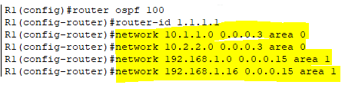

Verification:

OSPF area-0 and area-2 configured on R2:

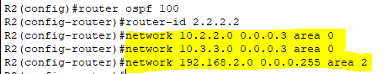

Verification:

OSPF area-0 configured on R3:

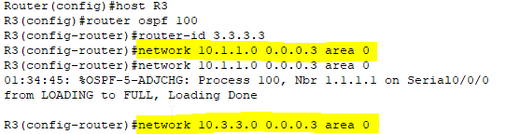

Verification:

1. **Two users in Engineering and Marketing groups each terminated on SW1 on VLAN 10 and 20 with default gateway on R1.**

Configuration of VLAN 10 and VLAN 20 configured on SW1:

SW1(config)#vlan 10

SW1(config-vlan)#name Engineering

SW1(config-vlan)#exit

SW1(config)#int f0/2

SW1(config-if)#switchport mode access

SW1(config-if)#switchport access vlan 10

SW1(config-vlan)#exit

SW1(config)#vlan 20

SW1(config-vlan)#name Marketing

SW1(config-vlan)#exit

SW1(config)#int f0/3

SW1(config-if)#switchport mode access

SW1(config-if)#switchport access vlan 20

SW1(config-if)#exit

SW1(config)#int f0/1

SW1(config-if)#switchport mode trunk

SW1(config-if)#switchport trunk allowed vlan 10,20

Verification of VLAN 10 and VLAN 20 configured on SW1:

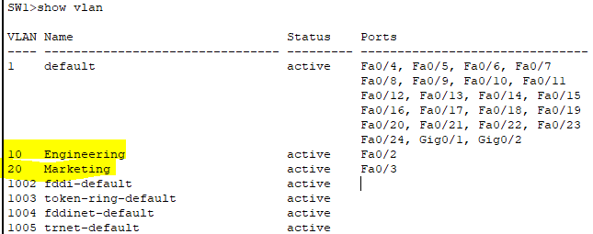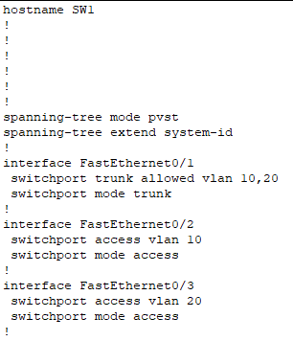

Encapsulation on R1:

**4. Two users in CustomerService group terminted on SW2 on VLAN 30 with default gateway on R2**

Configuration of VLAN 30 configured on SW2:

SW2(config)#vlan 30

SW2(config-vlan)#name CustomerService

SW2(config-vlan)#exit

SW2(config)#int f0/2

SW2(config-if)#switchport mode access

SW2(config-if)#switchport access vlan 30

SW2(config-if)#int f0/3

SW2(config-if)#switchport mode access

SW2(config-if)#switchport access vlan 30

SW2(config-if)#exit

SW2(config)#int f0/1

SW2(config-if)#switchport mode trunk

SW2(config-if)#switchport trunk allowed vlan 30

Verification of VLAN 30 configured on SW2:

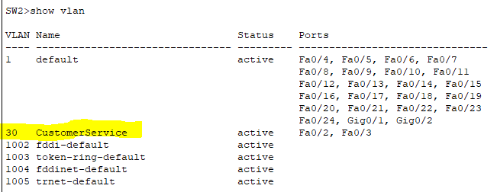

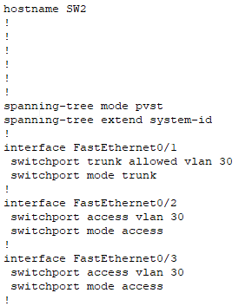

Encapsulation on R2:

**5. R3 connected to the InternetRouter. Configure a default route pointing to the InternetRouter and propagate the route into ospf**

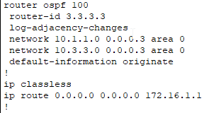

**6. Use the following IP Adddressing Scheme:  
   -Engineering and Marketing to use any two /28 subnets of the network 192.168.1.0   
   -CustomerService to use the network 192.168.2.0/24  
   -R3 link to the Internet to use network 172.16.1.0/24  
   -Backbone links to use any class-A network with /30 subnetting**

All the interfaces are configured as per the requirement are displayed on the addressing table

Verification:

R1:

R2:

R3:

**7. Manually configure ospf router ID's on R1 - R3**

OSPF configuration on routers are performed on step 2

Verification of OSPF on R1:

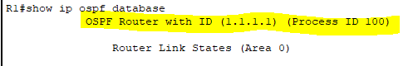

Verification of OSPF on R2:

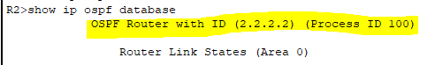

Verification of OSPF on R3:

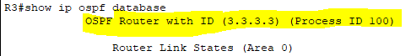

**8. Configure address summarization where feasible**

Area 0:

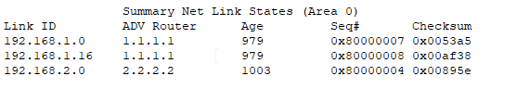

Area 1:

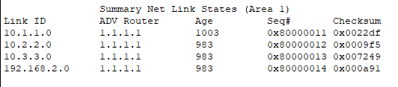

Area 2:

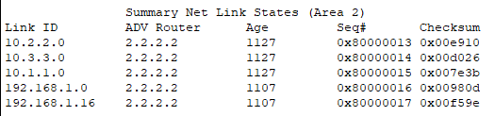

Perform route summarization for area 1 on R1:

R1(config)# router ospf 100

R1(config-router)# area 1 range 192.168.1.0 255.255.255.224

Summary net link states of the areas after area 1 summarization:

Area 0:

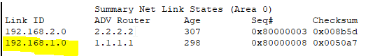

Area 1:

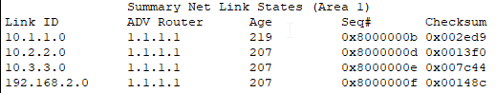

Area 2:

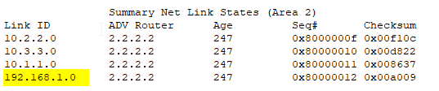

OSPF routes on R3:

